### Cart based components

### Create Cart

**Use Case Name: Create Cart**

**Author Name: Sajjad Patel, Soutrik, Michael**

**Applicable Business Rule:**

* Customer creates a purchase cart

**Use Case Preconditions:**

- Customer must be signed in to the system

- Customer must not have a cart already in progress

**Use Case Successful Post Conditions:**

* A cart is created with products of the customer's choice

**Main Flow:**

1. Customer chooses items from the catalogue
2. Customer creates a cart based off the chosen items
3. System creates cart

**Alternative Flows:**

1. Item is currently not in stock
   1. System displays current stock of item
   2. Customer updates their cart to update based off the current stock
   3. Customer clicks update
   4. System Creates Cart

### Update Cart

**Use Case Name: Update Cart**

**Author Name: Sajjad Patel, Soutrik, Michael**

**Applicable Business Rule:**

* Customer wants to update their cart

**Use Case Preconditions:**

- Customer must be signed in

- Customer must have a cart already created

**Use Case Successful Post Conditions:**

* Cart is successfully updated

**Main Flow:**

1. Customer clicks cart
2. System retrieves customers cart
3. Customer updates the cart by adding or removing products
4. Customer clicks update
5. System recreates updated cart

**Alternative Flows:**

1. Item is currently not in stock
   1. System displays current stock of item
   2. Customer updates their cart to update based off the current stock
   3. System Creates Cart

### Delete Cart

**Use Case Name: Delete Cart**

**Author Name: Sajjad Patel, Soutrik, Michael**

**Applicable Business Rule:**

* Customer wants to delete cart

**Use Case Preconditions:**

- Customer must have a cart already created

**Use Case Successful Post Conditions:**

* Cart is successfully deleted

**Main Flow:**

1. Customer Clicks on Cart
2. System retrieves customer`s cart
3. Customer clicks delete cart
4. System asks for confirmation
5. System removes cart from system

**Alternative Flows:**

1. Customer decides to not delete cart
   1. Customer clicks no for confirmation
   2. System redisplays cart with all chosen products

### Retrieve Cart

**Use Case Name: Retrieve Cart**

**Author Name: Sajjad Patel, Soutrik, Michael**

**Applicable Business Rule:**

* Customer wants to review their current cart

**Use Case Preconditions:**

- Customer must be signed in

- Customer must have a cart already created

**Use Case Successful Post Conditions:**

* Customer retrieves previously created carts

**Main Flow:**

1. Customer clicks on cart
2. System displays list of carts created
3. Customer can choose from current cart or previously created carts
4. Customer chooses previously created carts
5. Customer reviews information

**Alternative Flows:**

1. Customer Chooses to update current cart
   1. Customer clicks on current cart
   2. Customer updates information on cart
   3. Customer clicks update
   4. System saves cart information
2. Customer chooses to delete current cart
   1. System clicks on current cart
   2. Customer chooses to delete current cart
   3. System displays confirmation message
   4. Customer clicks confirms
   5. System deletes current cart

Activity Diagrams for Cart

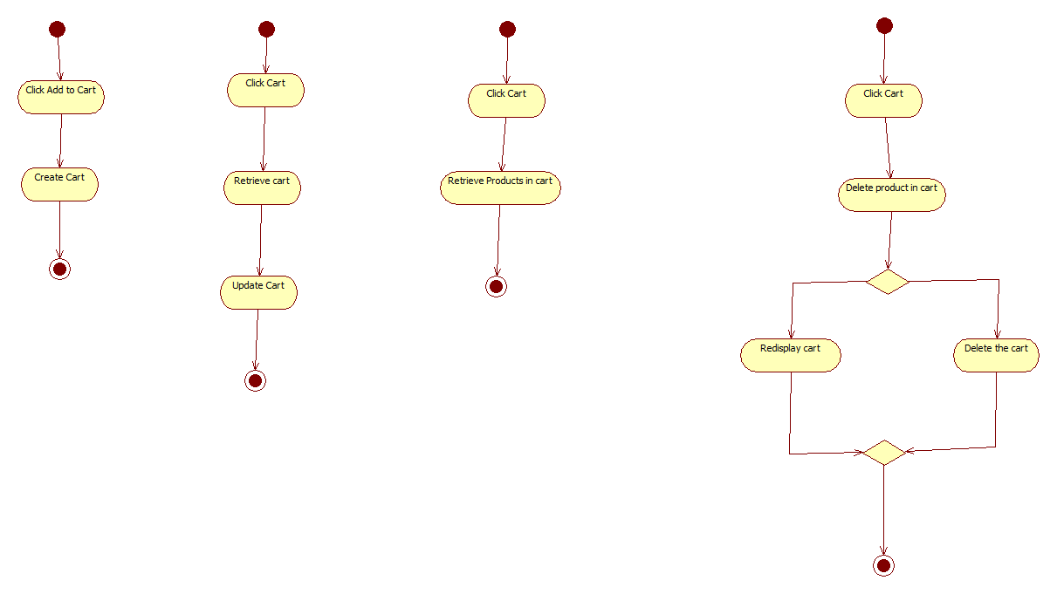

### Account based components

### Register Account

**Use Case Name: Register Account**

**Author Name: Sajjad Patel, Soutrik Barua, Michael Vuong**

**Applicable Business Rule:**

* Customer can register his/her account on the website only using e-mail.

**Use Case Preconditions:**

Person must have a valid e-mail address to go further on with the registration.

**Use Case Successful Post Conditions:**

A new account is made.

**Main Flow:**

1. Customer clicks on register account
2. System retrieves registration form
3. Customer fills out their basic information,address,e-mail etc.
4. Customer fills out the form and clicks register
5. System updates registration

**Alternative Flows:**

1. Wrong input field provided
   1. System refreshes registration page with correct information pre loaded
   2. User types in correct information in the incorrect fields
   3. System updates registration

### Delete User

**Use Case Name: Delete Account**

**Author Name: Sajjad Patel, Soutrik, Michael**

**Applicable Business Rule:**

* Customer can delete his/her account on the website only if registered

**Use Case Preconditions:**

Person must have a valid account

**Use Case Successful Post Conditions:**

An account is deleted.

**Main Flow:**

1)Customer clicks on delete account

2)System retrieves delete form

3)Customer fills out the form and clicks delete account

4)System updates user base.

**Alternative Flows:**

1. Wrong input field provided
   1. System refreshes delete page with correct information pre loaded
   2. User types in correct information in the incorrect fields
   3. System updates user base

### Update User

**Use Case Name: Update Account**

**Author Name: Sajjad Patel, Soutrik Barua, Michael Voung**

**Applicable Business Rule:**

* Customer can update his/her account on the website with a valid account.

**Use Case Preconditions:**

Person must have a valid account

**Use Case Successful Post Conditions:**

An account is updated.

**Main Flow:**

1)Customer clicks on update account

2)System retrieves account information form

3)Customer fills out the fields to be updated on the form and clicks update account

4)System updates user base.

**Alternative Flows:**

1. Wrong input field provided
   1. System refreshes delete page with correct information pre loaded
   2. User types in correct information in the incorrect fields
   3. System updates user base

Activity Diagrams for account



**Use Case Name: Delete Order**

**Author Name: Sajjad Patel, Soutrick, Michael**

**Applicable Business Rule:**

* Y.R Distribution: Wants to be able to delete order

**Use Case Preconditions:**

Person that wants to make these changes must be signed in and must be a manager or an employee depending on the changes being made.

**Use Case Successful Post Conditions:**

* Order must be deleted

**Main Flow:**

1. Employee/Manager Clicks on Orders
2. System retrieves all the Orders
3. Employee/Manager Clicks Delete Next to Order to be deleted
4. System Deletes Order

**Alternative Flows:**

1. Sign in wrong
   1. System opens password recovery page
   2. User types in email address
   3. System emails customer password

**Use Case Name: Retrieve Order**

**Author Name: Sajjad Patel, Soutrick, Michael**

**Applicable Business Rule:**

* Y.R Distribution: Wants to be able to retrieve orders

**Use Case Preconditions:**

Person that wants to make these changes must be signed in and must be a manager or an employee depending on the changes being made.

**Use Case Successful Post Conditions:**

* Order is retrieved

**Main Flow:**

1. Employee/Manager Clicks on orders
2. System retrieves all the orders

**Alternative Flows:**

1. Sign in wrong
   1. System opens password recovery page
   2. User types in email address
   3. System emails customer password

**Use Case Name: Update Order Status**

**Author Name: Sajjad Patel, Soutrick, Michael**

**Applicable Business Rule:**

* Y.R Distribution: Wants to be able to update order

**Use Case Preconditions:**

Person that wants to make these changes must be signed in and must be a manager or an employee depending on the changes being made.

**Use Case Successful Post Conditions:**

* Order status is updated

**Main Flow:**

1. Employee/Manager Clicks on Orders
2. System retrieves all the Orders
3. Employee/Manager Clicks Update Next to order to be updated
4. System retrieves update page
5. Employee/Manager clicks on dropdown menu and click Processing or Shipped
6. System updates Order Status

**Alternative Flows:**

1. Sign in wrong
   1. System opens password recovery page
   2. User types in email address
   3. System emails customer password

ACTIVITY DIAGRAM

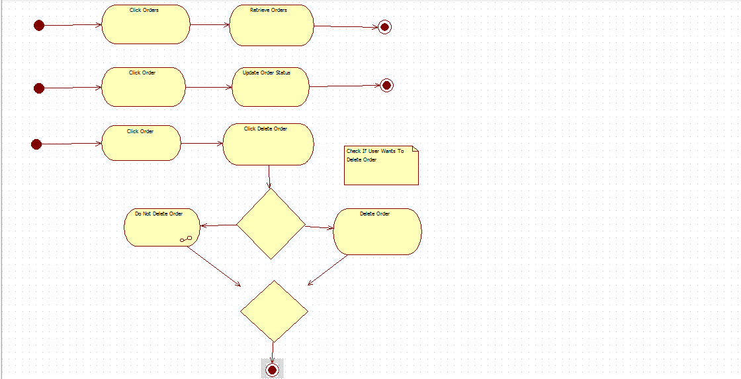

**Use Case Name: Create Product**

**Author Name: Sajjad Patel, Soutrick, Michael**

**Applicable Business Rule:**

* Y.R Distribution: Wants to be able to create products

**Use Case Preconditions:**

Person that wants to make these changes must be signed in and must be a manager or an employee depending on the changes being made.

**Use Case Successful Post Conditions:**

* Product must be created

**Main Flow:**

1. Employee/Manager Clicks on Products
2. System retrieves all the products
3. Employee/Manager Clicks Create Product
4. System retrieved create page for product
5. Employee/Manager Fills in information and clicks Create
6. System Creates Product

**Alternative Flows:**

1. Sign in wrong
   1. System opens password recovery page
   2. User types in email address
   3. System emails customer password
2. Invalid Information
   1. System redisplays Page to User
   2. User fixes the areas that have a red asterisk and clicks Create
   3. System Creates Product

**Use Case Name: Delete Product**

**Author Name: Sajjad Patel, Soutrick, Michael**

**Applicable Business Rule:**

* Y.R Distribution: Wants to be able to delete products

**Use Case Preconditions:**

Person that wants to make these changes must be signed in and must be a manager or an employee depending on the changes being made.

**Use Case Successful Post Conditions:**

* Product must be deleted

**Main Flow:**

1. Employee/Manager Clicks on Products
2. System retrieves all the products
3. Employee/Manager Clicks Delete Next to Product to be deleted
4. System Deletes Product

**Alternative Flows:**

1. Sign in wrong
   1. System opens password recovery page
   2. User types in email address
   3. System emails customer password

**Use Case Name: Retrieve Product**

**Author Name: Sajjad Patel, Soutrick, Michael**

**Applicable Business Rule:**

* Y.R Distribution: Wants to be able to Retrieve products

**Use Case Preconditions:**

Person that wants to make these changes must be signed in and must be a manager or an employee depending on the changes being made.

**Use Case Successful Post Conditions:**

* Product must be retrieved

**Main Flow:**

1. Employee/Manager Clicks on Products
2. System retrieves all the products

**Alternative Flows:**

1. Sign in wrong
   1. System opens password recovery page
   2. User types in email address
   3. System emails customer password

**Use Case Name: Update Product**

**Author Name: Sajjad Patel, Soutrick, Michael**

**Applicable Business Rule:**

* Y.R Distribution: Wants to be able to Update Product

**Use Case Preconditions:**

Person that wants to make these changes must be signed in and must be a manager or an employee depending on the changes being made.

**Use Case Successful Post Conditions:**

* Product must be Updated

**Main Flow:**

1. Employee/Manager Clicks on Products
2. System retrieves all the products
3. Employee/Manager Clicks Edit Next to Product to be Edited
4. System Retrieves Product Edit Page
5. Employee/Manager Updates Product Information and clicks Submit
6. System Updates Product Information

**Alternative Flows:**

1. Sign in wrong
   1. System opens password recovery page
   2. User types in email address
   3. System emails customer password
2. Invalid Information
   1. System redisplays product edit page with red asterisk next to fields of invalid information
   2. User fills in correct information and clicks submit
   3. System updates product

ACTIVITY DIAGRAMS

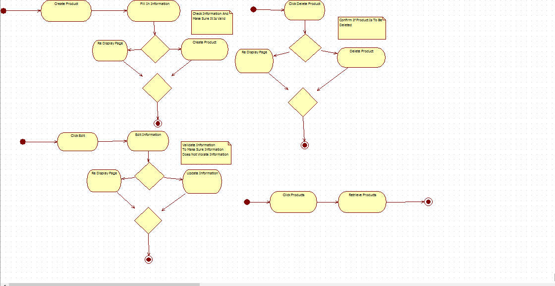

### Category based components

### Create Categories

**Use Case Name: Create Category**

**Author Name: Sajjad Patel, Soutrik Barua, Michael Voung**

**Applicable Business Rule:**

* Y.R Distribution: categories can only be created if certain products exists.

**Use Case Preconditions:**

Person that wants to make these changes must be signed in and must be a manager or an employee depending on the changes being made.

**Use Case Successful Post Conditions:**

* Category Must Be Created

**Main Flow:**

1)Employee/Manager Clicks on Categories

2)System retrieves all the categories

3)Employee/Manager Clicks Create Category

4)System Retrieves Create Page

1. Employee/Manager fills in information and clicks Create
2. System Creates Category

**Alternative Flows:**

1. Sign in wrong
   1. System opens password recovery page
   2. User types in email address
   3. System emails customer password
2. Invalid Information
   1. System redisplays page with red asterisk next to areas of invalid information
   2. User fills in correct information and clicks create
   3. System creates category

### Delete Categories

**Use Case Name: Delete Category**

**Author Name: Sajjad Patel, Soutrik, Michael**

**Applicable Business Rule:**

* Y.R Distribution: categories cannot be deleted if product using those categories exists.

**Use Case Preconditions:**

Person that wants to make these changes must be signed in and must be a manager or an employee depending on the changes being made.

**Use Case Successful Post Conditions:**

* Category must be deleted

**Main Flow:**

1)Employee/Manager Clicks on Categories

2)System retrieves all the Categories

3)Employee/Manager Clicks Delete Next to Category to be deleted

4)System Deletes Category

**Alternative Flows:**

1. Sign in wrong
   1. System opens password recovery page
   2. User types in email address
   3. System emails customer password

### Retrieve Categories

**Use Case Name: Retrieve Category**

**Author Name: Sajjad Patel, Soutrik, Michael**

**Applicable Business Rule:**

* Y.R Distribution: categories can be retrieved if they existed before.

**Use Case Preconditions:**

Person that wants to make these changes must be signed in and must be a manager or an employee depending on the changes being made.

**Use Case Successful Post Conditions:**

* Categories are retrieved

**Main Flow:**

1)Employee/Manager Clicks on Categories

2)System retrieves all the categories

**Alternative Flows:**

1. Sign in wrong
   1. System opens password recovery page
   2. User types in email address
   3. System emails customer password

### Update Categories

**Use Case Name: Update Category**

**Author Name: Sajjad Patel, Soutrik, Michael**

**Applicable Business Rule:**

* Y.R Distribution: categories can be updated if already existed.

**Use Case Preconditions:**

Person that wants to make these changes must be signed in and must be a manager or an employee depending on the changes being made.

**Use Case Successful Post Conditions:**

* Category is updated

**Main Flow:**

1)Employee/Manager Clicks on Categories

2)System retrieves all the Categories

3)Employee/Manager Clicks edit Next to category to be edited

4)System retrieved edit page

5)Employee/Manager fills information to be changed

6)System updated category

**Alternative Flows:**

1. Sign in wrong
   1. System opens password recovery page
   2. User types in email address
   3. System emails customer password
2. Invalid information
   1. System retrieves page and displays it back to user with red asterisk next to fields to be fixed
   2. User fixes information and submits correct information
   3. System updates category

ACTIVITY DIAGRAM

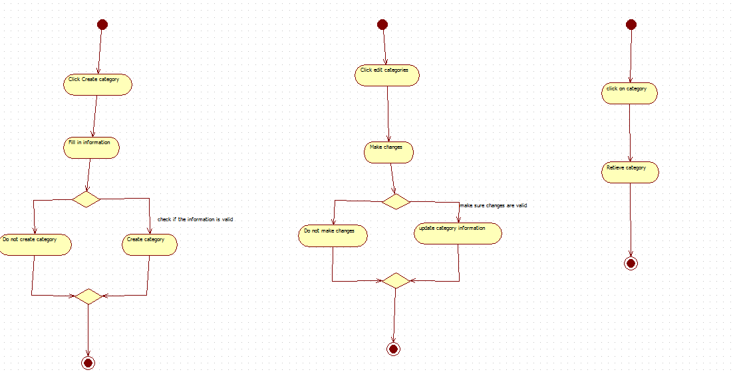

*************************************************************************************

### Promotion Based Component

* Create Promotions

**Use Case Name : Create Promotions**

**Author Name : Sajjad Patel, Soutrik Baura, Michael Vuong**

**Applicable Business Rules :**

- Y.R Distribution : Wants to create promotion

**Use case Preconditions :**

Person that wants to make the promotions must be signed in and this option is only available to the CEO

**Use Case Successful Post Conditions**

- CEO creates his or her desired promotion

**Main Flow**

1. CEO Clicks promotions
2. System displays options for promotion types or custom promotions available
3. CEO clicks create promotion
4. System retrieves create page
5. CEO fills in information for promotion and clicks create
6. System creates promotion

**Alternative Flows:**

1. Sign in wrong
   1. System opens password recovery page
   2. User types in email address
   3. System emails customer password
2. Invalid Information
   1. System redisplays page with red asterisk next to areas of invalid information
   2. User fills in correct information and clicks create
   3. System creates category

### Update Promotion

**Use Case Name : Update Promotions**

**Author Name : Sajjad Patel, Soutrik Baura, Michael Vuong**

**Applicable Business Rules :**

- Y.R Distribution : Wants to update an existing promotion

**Use case Preconditions :**

Person that wants to make the promotions must be signed in and this option is only available to the CEO.

Promotion must have been created previously by the CEO.

**Use Case Successful Post Conditions**

- CEO updates his or her desired promotion

**Main Flow**

1. CEO Clicks promotions
2. System displays options for promotion types or custom promotions available
3. CEO clicks update promotion
4. System retrieves page of current available promotions
5. CEO fills in information for promotion and clicks update
6. System updates promotion

**Alternative Flows:**

1. Sign in wrong
   1. System opens password recovery page
   2. User types in email address
   3. System emails customer password
2. Invalid Information
   1. System redisplays page with red asterisk next to areas of invalid information
   2. User fills in correct information and clicks create
   3. System creates category
3. Promotion does not exist
   1. System displays error and redirects to create promotion page
   2. User fills in information for creating a promotion
   3. System creates new promotion

### Delete Promotion

**Use Case Name : Delete Promotions**

**Author Name : Sajjad Patel, Soutrik Baura, Michael Vuong**

**Applicable Business Rules :**

- Y.R Distribution : Wants to Delete an existing promotion

**Use case Preconditions :**

Person that wants to make the promotions must be signed in and this option is only available to the CEO

**Use Case Successful Post Conditions**

- CEO removes his or her desired promotion

**Main Flow**

1. CEO Clicks promotions
2. System displays options for promotion types or custom promotions available
3. CEO clicks delete promotion
4. System retrieves current promotions page
5. CEO chooses from the list on which promotion to remove
6. System returns a confirmation request for the deletion request
7. CEO chooses confirm deletion
8. System removes promotion from system

**Alternative Flows:**

1. Sign in wrong
   1. System opens password recovery page
   2. User types in email address
   3. System emails customer password
2. Invalid Information
   1. System redisplays page with red asterisk next to areas of invalid information
   2. User fills in correct information and clicks create
   3. System creates category

### Retrieve Promotion

**Use Case Name : Retrieve Promotions**

**Author Name : Sajjad Patel, Soutrik Baura, Michael Vuong**

**Applicable Business Rules :**

- Y.R Distribution : Wants to display a list of current promotions

**Use case Preconditions :**

Person that wants to view the promotions must be signed in and this option is only available to the CEO

**Use Case Successful Post Conditions**

- CEO views his or her desired promotion

**Main Flow**

1. CEO Clicks promotions
2. System displays options for promotion types or custom promotions available
3. CEO clicks view all current promotion
4. System retrieves current promotion page
5. CEO confirms and validates that every promotion is correct

**Alternative Flows:**

1. Sign in wrong
   1. System opens password recovery page
   2. User types in email address
   3. System emails customer password
2. Invalid Information
   1. System redisplays page with red asterisk next to areas of invalid information
   2. User fills in correct information and clicks create
   3. System creates category
3. No Promotions Are Currently Active
   1. Systems displays that there are no promotions that are available
   2. CEO clicks create promotion
   3. System displays create promotion page
   4. CEO fills in promotion information
   5. System creates promotion

ACTIVITY DIAGRAMS

